1. **Navayushya Booking page should be like [But No online payment] :** <http://auraveda.in/index.php/wellness/book>
2. **Create “CALL FOR AN APPOINTMENT” button in a box [see the image below] like the site** <https://www.thespaatfgv.com/>

When a visitor clicks the button - in his MOBILE Phone - Our number with dialpad should open. Please try in your mobile with the above link.

See the photo to get an idea [for you]--- >>

Also Change the heading “**Navayushya Ayurveda**” to “R**ejuvenating Experience**”

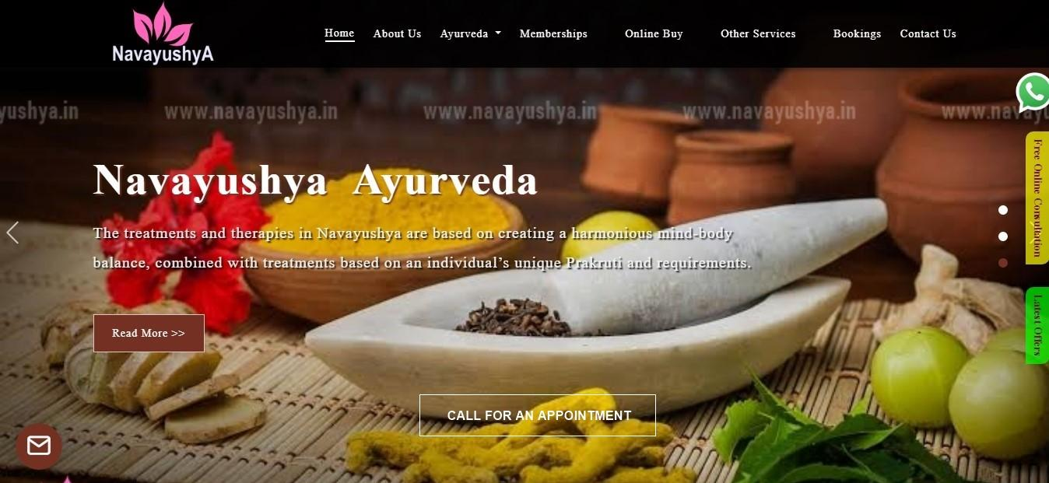

1. **Contact us page :**

<https://www.thespaatfgv.com/contact-us.html>

1. **Free online consultation - all the items same.**

<https://www.kairali.com/onlineconsultation.aspx>

1.  Please change the phone number to +916238791097
2. Chat with WhatsApp - New logo file to use. Also change the WhatsApp number to +916238791097



1. **Movements & some features :**

Can we create some movements in the home page like features in the following website.

<https://www.monart.ie/>

Contents appear when we scroll down from top to bottom at first visit to this page.

1. **On the home screen sliding images**

Heading - content & Booking Tab

Heading - content & Gift Card Tab

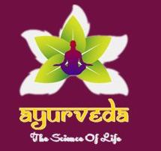

Ayurveda The Science Of Life - is to be repalced with the file below.



1. In the Menu Bar - Gap between the options has to be same. Means Gap between “Home” & “About us” is less. Whereas gap between Memberships-Online Buy-Other services is more. Please arrange this.

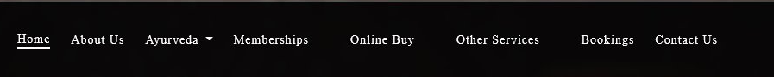

1. Please remove the address ‘**Navayushya, Delhi, NCR**’ from the header & Put new address :

**‘Q1-282, Ground floor, South City 2, Sector 49, Gurugram 122018’**



1. In the above header Change the colour  to . We don’t need the brown shade in this website.
2. Please reduce size of these logos a little

 

1. There is asymmetry in this area. So reduce the content in ‘Beauty Facials’. Trimmed content : “Facials as per the traditional Ayurvedic formulas laid down in scriptures”

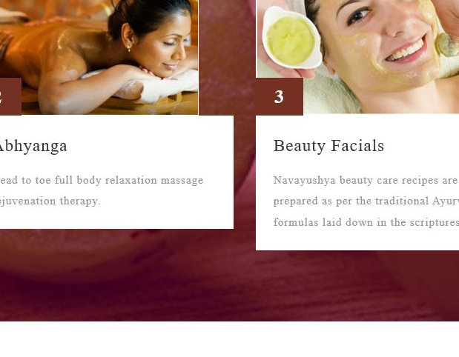

1. Current chat in the website has to be replaced with **Zen desk chat**